jc_isscc_final_v3.ppt

C:\Documents and Settings\Administrator\Desktop\isscc_final\jc_isscc_final_v3.ppt

Document created on: 2/7/2009

Slide 1 |  | - Thank the speaker  - Greet the audience
Slide 2 | 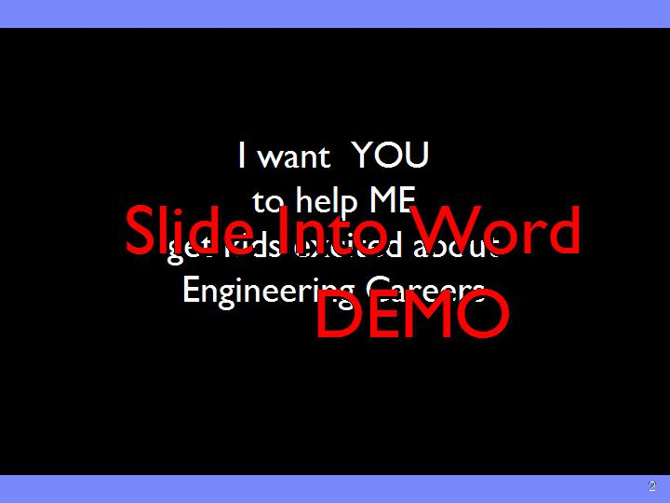 | - READ: Read chart  - US: Not about what others are should do.. (eg. Politicians) I’ts about what WE can do  - LOVE: Ask about LOVE  - Hold on to that love and passion to inspire the next generation.  - Fall back in love with the field doing it
Slide 3  Animation Clicks: 5 | 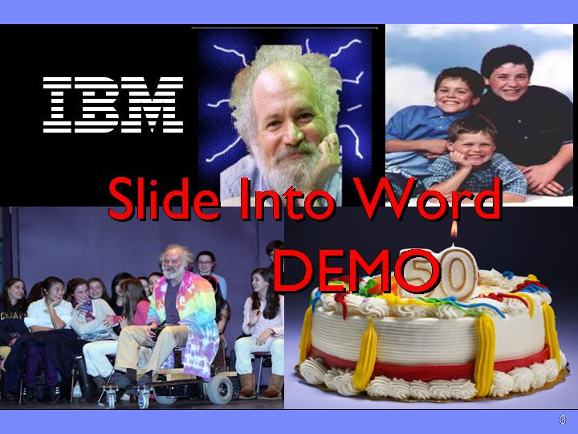 | - First a little background… I’ not an educator.. I’ an engineer like you  - GEEK  - FELLOW  - DAD  - VOLUNTEER  - BIRTHDAY  - Sam story  <Tesla coil ?
Slide 4  Animation Clicks: 5 | 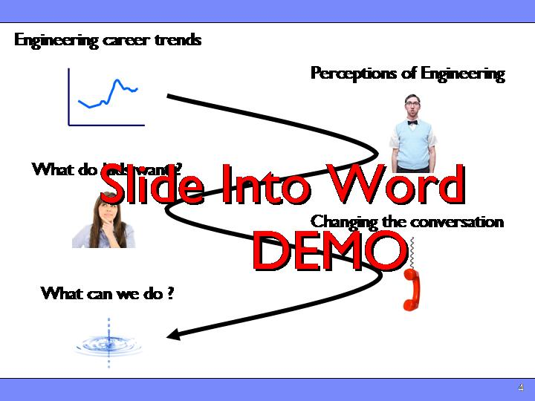 | Path of our talk  - Review a few career trends and stats  - Look at perceptions of engineering  - See how that lines up around what kids want  - See how we can help change the conversation  - Finally.. Most importantly, talk about you can help !
Slide 5  Animation Clicks: 1 | 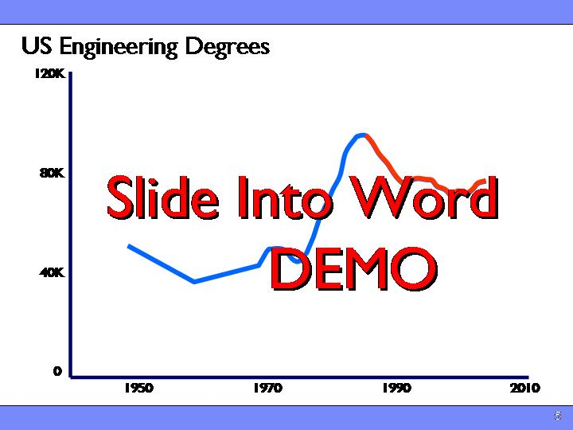 | - Let’s look at where are we today  - DOWN 15%: US first Engineering degrees are down roughly 15 % in 2 decades since peak in late 80’s  - CRISIS: Called engineering crisis  - Flattening out, some increase in certain fields.. But certainly not good  Refs  Courtesy . Prof D. Grasso Dean CESM UVM
Slide 6  Animation Clicks: 5 | 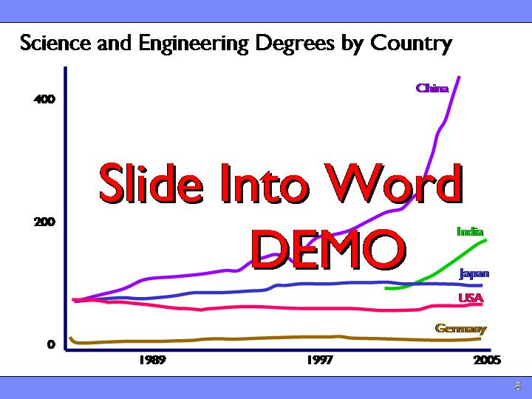 | - Let’s look at the world trends…  - FLAT: You can see with many of the merged economy's.. Flat, small decrease.. Certainly not stellar growth  - INDIA/CHINA: The notable exceptions to this are the rapidly growing countries of india and china.  Refs:  - NSF S&E Indicators 2008, Higher Education in S&E. http://www.nsf.gov/statistics/seind08/c2/c2s5.htm#c2s52, Figure 2.35  - India data: Issues in Science and Technology Online Seeing through Preconceptions: A Deeper Look at China and India, V. Wadhwa e.t al., http://www.issues.org/23.3/wadhwa.html, Table 1.
Slide 7  Animation Clicks: 3 | 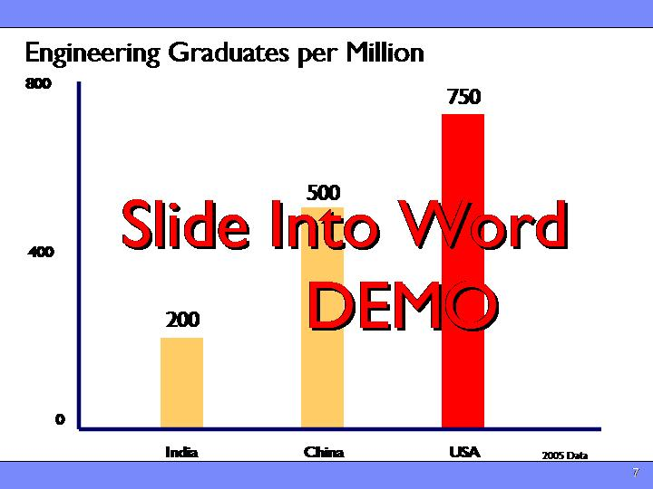 | - Read data  - PER CAPITA: even in those boom economies, the number of new engineers graduated per capita still lags somewhat behind that of the west. .. Though the gap is closing  - IQ: Wealth is not evenly distributed, but IQ is  Refs  - Us Vs India and China - Engineering Graduates Statistics. http://www.digi-help.com/pub/us-india-china-engineers-statistics.asp  - Where the Engineers Are , V. Wadhwa e.t all, Issues in Science and Technology, Spring 2007, p1  - India data: Issues in Science and Technology Online Seeing through Preconceptions: A Deeper Look at China and India, V. Wadhwa e.t al., http://www.issues.org/23.3/wadhwa.html, Table 1.
Slide 8 | 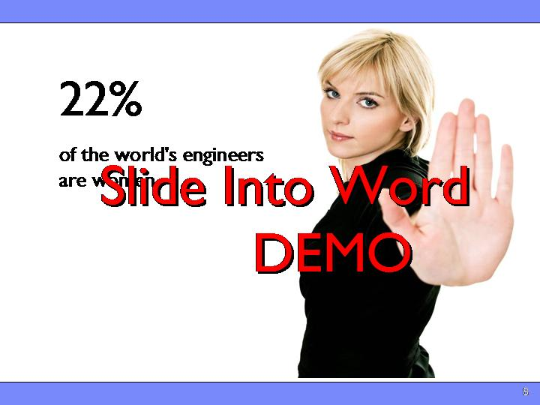 | - What is even more telling than any change in the number of engineers worldwide is what is not changing.  - 22 % WOMEN: world wide average.. That’s out of 51 % for the total population  - ABILITY: No difference in ability  - Similar worrying statistic in under-represented groups  - HISPANICS/AFRICAN AMERICANS : Hispanics make up 13 % of general population.. AA only 15% Only 5 % of each Engineers  - MEDICI: The statistics on both women and minorities in engineering are troubling because it means that we are not attracting a complete cross section of the population to our fields. Diversity in engineering is not only politically correct, it’s essential to diversity of thought. In his excellent book, the medici effect, author frans johansson points out that firms that have more diverse employees are more innovative, more successful, and more robust. A more diverse engineering population will also be more innovative and robust  - The skew in diversity points to a deep systemic problem in the way that we “market” our field to the next generation. Let’s take a look into this problem.  Refs  [2] NSF S&E Indicators 2008, Higher Education in S&E. http://www.nsf.gov/statistics/seind08/c2/c2s5.htm#c2s52, Appendix 2-39  [2] NSF, Women, Minorities and Persons with Disabilities in Science and Engineering. http://www.nsf.gov/statistics/wmpd/figb-1.htm. Figure B-1  [3] Engineering and Technology Education for Women: Prospects for Rural Women, M. A. Subramanian and Saxena, International Colloquium on Empowering Women in Engineering and Technology 6- 8 June 2007, Tunis  [3] People's Daily (China), More than a third Chinese engineers are female, http://wais.stanford.edu/ztopics/week120104/china_041201_womenengineers.htm  [5] http://www.nacme.org  [6]The Medici Effect: Breakthrough Insights at the Intersection of Ideas, Concepts, and Cultures, F. Johanssen, Harvard Business School Press, pp ?
Slide 9 |  | - RECAP  - We have seen decrease in eng, while some increasing.. Most parts of the world.. Not great.  - Women and minorities are down, Normalized, no so bad, But clearly not growing…  - CRISIS?: : is this a crisis ? , Depends where you live  - I’d Argue that the world financial crisis we find our selves in dwarfs the changes in eng trends  - Focusing on the stats leads us to good intentioned / but misguided.. Thinking in what we ask schools to do, Won’t measure our way out…  - OPPORTUNITY: You have the opportunity/pleasure/responsibility to pass on your passions  - So.. Let’s look at what might be behind those trends
Slide 10 | 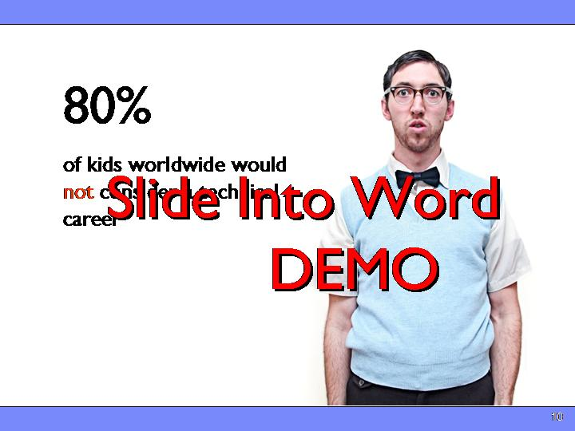 | - Why aren’t more high school graduates entering the field of engineering?  - 80% SAY ‘NO’: of kids in recent Worldwide study (PISA) said that they would not be interested in a Engineering/ technical career  - 44% Don’t Know: Though a recent NAE study uncovered that 44% of kids in the US could n’t say exactly what an engineer does.  - NO CLUE: In the words of the study: “the public has a poor idea of what engineers actually do on a day-to-day basis; and there is a strong sense that engineering is not “for everyone,” and perhaps especially not for girls. …  - A recent American Society of Quality (ASQ) /Harris survey in the US showed that:  - 30 % of Kids say that prefer a more exciting career than engineering  - But Only 20 percent of parent have encouraged/will encourage their child/children to consider an engineering career. .. It’s even less for Girls.. It’s 10 % !  - most students and parents could not name a single identifiable “public face” of engineering.  - NERD: We seem to be facing a major image problem. Surprisingly, the familiar stereotypes of engineers as being “nerds” or socially inept “geeks,” rarely surface in surveys on public opinion.  - As we’ll see .. The negative stereotypes that do come up around engineering are actually more worrisome  Refs  [2] The OECD Programme for International Student Assessment (PISA). http://www.oecd.org/dataoecd/15/13/39725224.pdf, p 29  [4] Changing the Conversation: Messages for Improving Public Understanding of Engineering, National Academies Press 2008
Slide 11  Animation Clicks: 10 | 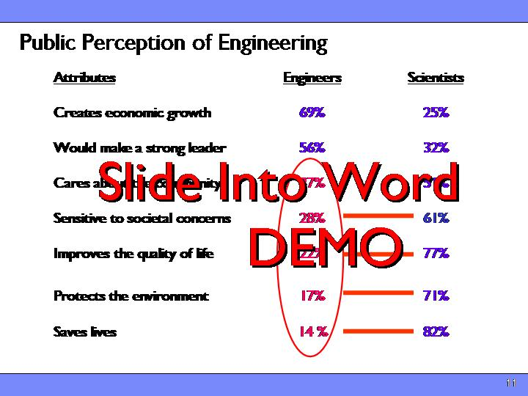 | - In a harris poll done several years ago for the American Association of Engineering Societies (AAES), individuals were asked to associate values to the field of engineering.  - As one would expect, a large number of respondents associated engineers with being good leaders and creating material value.  - SOCIETAL VALUE : Alarmingly, though, relatively few respondents associate engineers with generating “social value” such as caring about the community, saving lives, or being sensitive to societal concerns,  - SCIENTISTS DO: Even though they feel scientists do have these admirable traits. (engineer == scientist with a job)  - This is particularly surprising given the huge strides engineering has enabled in fields such as health care, energy, and even entertainment.  - In fact, more than 25 percent of students surveyed worldwide disagreed with the statement “advances in science and technology usually bring social benefit.” That number was considerably higher in western europe and considerably lower in the far east.  - CREDIT: Think about this for a moment…. Clearly we’re not getting credit for what we do in the world.  Refs:  [1] Changing the Conversation: Messages for Improving Public Understanding of Engineering, G. Pearson, National Academy of Engineering Office. Used with permission.  [6] The OECD Programme for International Student Assessment (PISA). http://www.oecd.org/dataoecd/15/13/39725224.pdf, p 31
Slide 12  Animation Clicks: 4 | 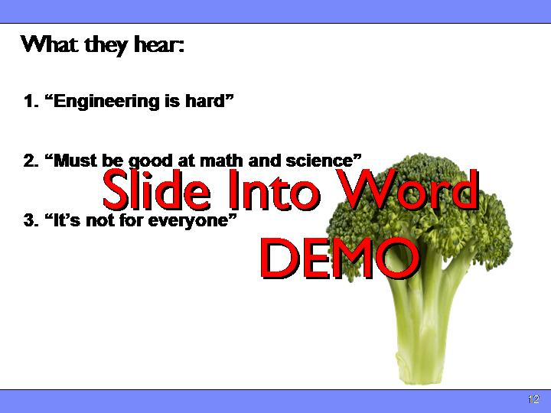 | - Why the gap between what we know about ourselves and what school-aged children and the general public believe?.  - To this end, the US National Academy of Engineering (NAE) conducted a 2006-8 study called “Changing the conversation” in which they surveyed thousands of students and parents about their perceptions of engineering.  - HARD, GOOD AT MATH, NOT FOR EVERYONE What students are hearing about our field is that it is difficult, that you must be good at math and science, and that you use those skills to solve challenging problems.  - MATH” 21 % don’t feel confident enough in their math or science skills to be good at it.  - 97 % of parents say that they believe that knowledge of math and science will help their children have a successful career.  - Like we’re selling Broccoli.. It might not taste good.. But it’s good for you…  Refs:  [2] Changing the Conversation: Messages for Improving Public Understanding of Engineering, National Academies Press 2008  [4] http://www.manufacturing.net/News-Survey-Kids-Saying-No-To-Engineering.aspx?menuid=36
Slide 13  Animation Clicks: 3 | 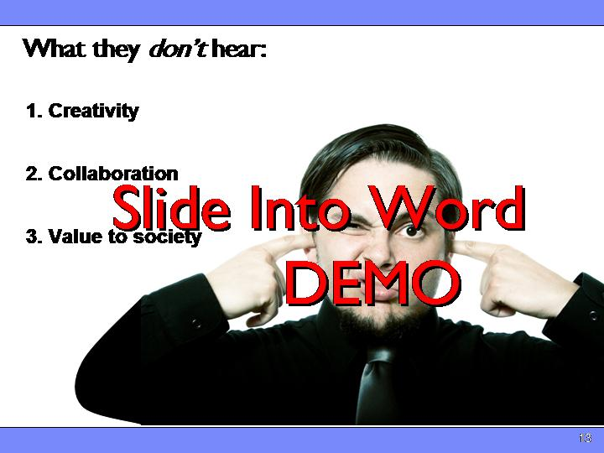 | - CREATIVTY, COLLABORATION, VALUE: While all of that is true, it does nothing to capture the creative core of what we do, nor does it say anything about the value we bring to the world.  - SEDNETARY/LONELY students thought that engineering was sedentary, and most work was done on computers with little contact with other people.”  - Think medical, energy, transportation.. Even entertainment  - CREDIT: Clearly not getting credit for what we do…  - contrast this to the view society has of the medical profession. The public’s first thoughts of medicine are not that it is difficult, you work long hours, and you need to be good at organic chemistry; instead we think of doctors as being brilliant, compassionate healers who bring health to suffering people. Now that’s a good brand message.  - $400M: Despite $400M/yr !!!  Refs  [1-4,6] “Raising Public Awareness of Engineering,” National Academies Press, p 2
Slide 14 | 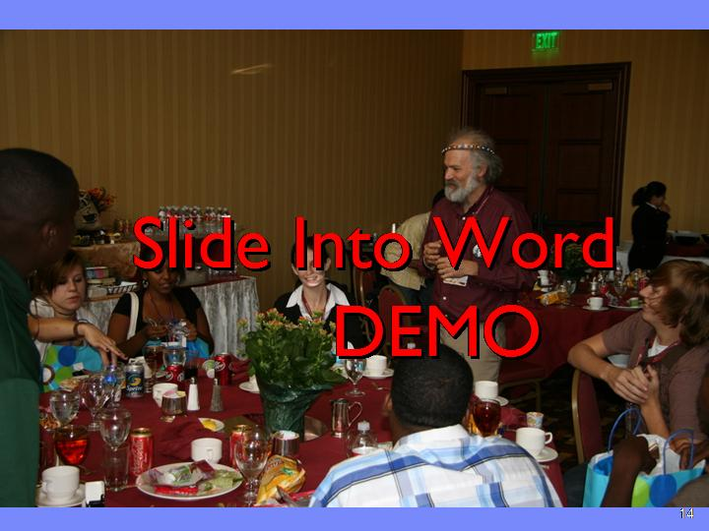 | <Austin story… >  - So Recap  - HARD/MATH NOT FOR EVERYONE :Kids have a vague idea of what we do  - NO REONATING VALUE: Don’t attribute high social value  - Hear about the hard parts,  - And aren't getting the fun parts despite considerable effort !  - It is tempting to look at the surveys and enrollment trends referenced above, particularly those in the west, and surmise that this generation does not want to work as hard as previous generations. There may be some truth in this, but to attribute the disconnect completely to unwillingness to work hard would be missing the point.  - FIGURE OUT: Lets look at what kids these days do want and see if we can figure out what’s up
Slide 15 | 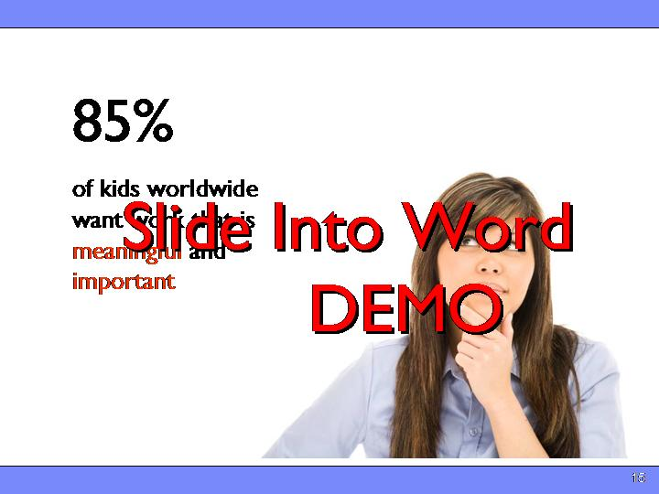 | - 85% WANT VALUE: a recent Survey (ROSE) of 40,000 students in 40 countries, 85% students are overwhelmingly looking for the transcendent values of “meaning” and “importance” in what they choose as a career, as demonstrated in .  - Compare that to 21 % who expressed interest in technology careers in the same study  - MILLINEALS: In their excellent book Millennials rising, Neil Howe and William Strauss explored the aspirations of the current generation entering the workforce now. Their data show that the attitudes of this generation have shifted away from pure materialism and towards higher goals such as self fulfillment.  More so than any generation since the 1960’s  - HOW DO WE KNOW: They illustrated this trend in several interesting ways  Refs:  [1] Relevance of Science Education (ROSE) study, Schreiner, Camilla & Sjøberg, Svein. http://www.ils.uio.no/english/rose/network/countries/norway/eng/nor-schreiner-values2006.pdf, p 7, Figure 2  [1] http://www.ils.uio.no/english/rose/network/countries/norway/eng/nor-schreiner-values2006.pdf
Slide 16  Animation Clicks: 1 | 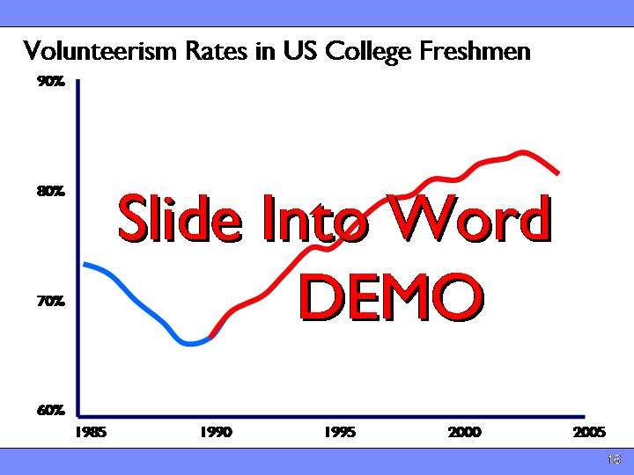 | - VOLUNTEER RATES Up 20% : First they looked at volunteer rates. This survey was done on a poll of entering US colleges freshmen  - TOP TEN JOBS: :In the past 2 years, Peace Corp, Teach for America now on Top Ten lists as dream jobs of entering Freshmen  - SINCE SAM STORY  Refs  [1,2] Millennials Rising: The Next Great Generation, N. Howe, Vintage Books 2004 Extracted from authors presentation .Used with permission.
Slide 17  Animation Clicks: 7 | 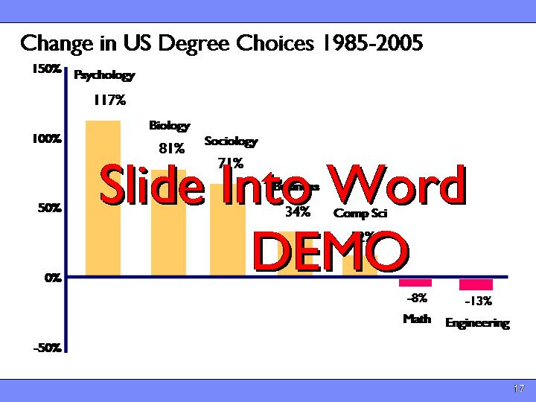 | - VALUES IN CAREER CHOICES: ? So.. How how is this shift towards higher vales being manifested in career choices ?  - I analyzed Data from US Dept of commerce data..  - MAKING A DIFFERNCE: Note that the fields one would normally associate with ‘making a difference’ .. are increasing the most  - LOOK AT ENGINEERING Growing faster than even with the huge run up in business and finance…. And that was before the bottom fell out of the markets.  - .  Refs  [1]National Science Board Digest Of Key Science And Engineering Indicators 2008. http://www.nsf.gov/statistics/seind08/append/c2/at02-28.xlsd, Di, table 2-28 augmented with data on business degrees from National Center for Education Statistics, Bachelor's degrees conferred by degree-granting institutions, by discipline division: Selected years, 1970-71 through 2005-06 http://nces.ed.gov/Programs/digest/d07/tables/dt07_261.asp
Slide 18 | 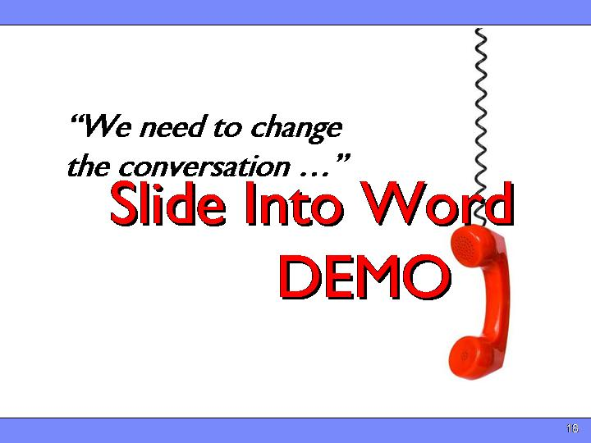 | - RECAP..  - WE ARE NOT RELEVANT Kids not associating social relevance with engineering  - WANT TO MAKE DIFFERENCE: At the same time, kids wish to make a difference is increasing worldwide..  - .. And kids aren’t hearing the carefully crafted messages we create to insist that we do have social value..  - Clearly kids are n’t hearing all of the story.. And worse.. They aren’t believing what we tell them to change those impressions ? Why  - NEED TO CHANGE CONVERSATION: in the words of the late, great paul newman: “what we have here is a failure to communicate.”
Slide 19  Animation Clicks: 9 | 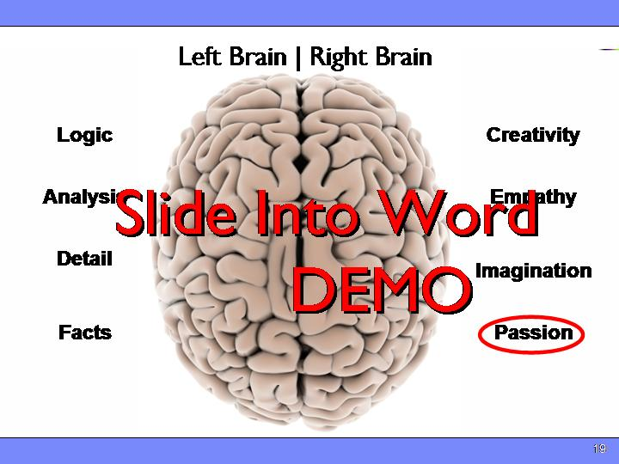 | - CLICHÉ: The more I think about it, the more I see an important source of the problem… . And believe it or not.. It starts deeply in the way people think.. Though it’s almost ‘cliché’.. Left brain/right brain, it’s something now backed up by FMRI  - LEFT/RIGHT ATTRIBUTES The left side of our brains has evolved to handle the concrete tasks of Logic, Analysis, Detail, sequence, etc. – the bedrock of our profession.. Right brain == Holistic.  - While the right has evolved to deal with more conceptual issues, like creativity, association, empathy, emotions and Passions..  - WOMEN MORE RIGHTBRAIN Women on average are known to have more right brain focus than men  - The traditional message we give.. And kids hear about engineering has appealed almost exclusively to the left-brain attributes of engineering such as applying math and science, precision and reason. Some how.. We don’t seem to be getting through on the right hand attributes  - WHOLE NEW MIND: In his excellent book, A Whole New Mind, Author Daniel Pink argues that in an age of abundance, automation, and globalization, the traditional left-brained skills of accuracy, precision, and efficiency, which have sustained our field for the past century, will cease to be sufficient differentiators in the global marketplace. Instead, he argues, goods and services will increasingly also need to appeal to the more right-brained attributes of creativity, social value, and play to differentiate themselves in world markets. He similarly argues that individuals, companies and whole nations that can best harness creativity and passion will have a competitive advantage in the world.  - We need to change the conversation to emphasize the additional right-brained attributes we use everyday, including creativity, passion, and commitment to help society and the world.  - Note that we say “additional” because in changing the message we cannot lose the essence of what we do. Math and science skills are, after all, still central to our profession.  - NOT DUMBING DOWN: Now.. I hear you thinking this sounds like a sell out.. I’m not talking about Adding… not subtracting..  - I’m NOT saying dumb it down  - I’m not saying make it align with their values  - I’m saying let’s spend more time making sure that the next generation sees our personal passions, our relevance and our commitment to help the world..  12. Where start ? So .. How do these stereotypes get reinforced ?  Refs  [5] A Whole New Mind, D. Pink, Riverhead Books, 2005,
Slide 20  Animation Clicks: 3 | 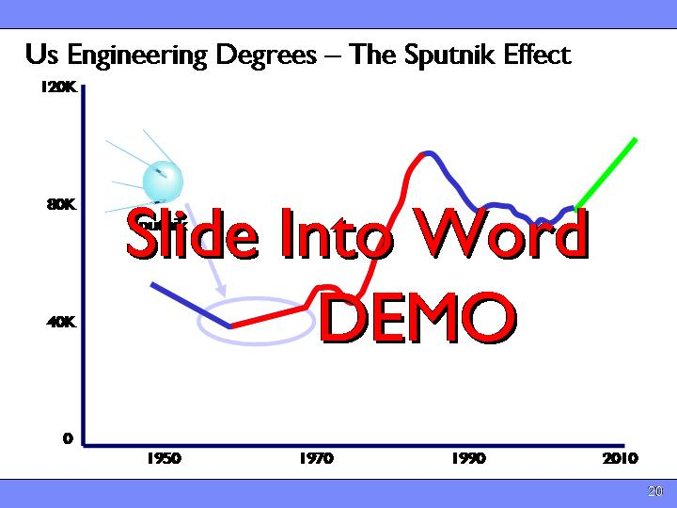 | - So, what can we do to reengage the right brains of the next generation ?  - Let’s go back to the last time we captured the imagination creativity and passion of a whole generation..  - SPUTNICK: Think back to 1957.. (if you can).. Time of great political and econmic crisis.. S  - All that changed when the then Soviet Union launched very public grapefruit sized technical marvel.. Sputnick  - As it circled overhead emitting it’s simple beats broadcast through raids around the world went right into the tight brains of thousands of kids.  - MOON SHOT: Pres kenendy made his moon launch speech.. Send a man to the moon and bring him saftley home.  - Overnight kids were lining up for engineering and science .. Gave us 2 solid decades of growth  - What we need is a new “sputnik” to galvanize the next generation of students’ interest in science and technology. Luckily, we have a perfect one staring us right in the face: :  Refs  - Courtesy . Prof D. Grasso Dean CESM UVM
Slide 21 |  | - I know that I’m not breaking new ground here… but the answer is so clear.. We have the next grand challenge it’s the crisis around climate, the environment, and energy. I  - 79% AGREE: 79% of children surveyed worldwide in both (ROSE) and (PISA) understand some aspect of the challenges posed by global warming, and understand the role that science and technology can play in reducing its impact. That’s an unprecedented degree of consensus  - This world crisis can and should be an important tipping point for our industry. In addition to requiring changes in policy and human behavior, mitigating the impact of the environmental crisis is going to require new technologies in energy generation and storage, environmental monitoring, modeling, transportation, and information technology.  - NEW GREEN JOBS: News outlets worldwide are predicting millions of new “green jobs” and many of those jobs are going to be in our industry. And kids , parents and teachers are hearing and absorbing that message  - CONCRETE: What’s more, the concrete “making things” nature of these engineering jobs is going to look much more inviting to students who might have been considering careers in business or finance before the current worldwide economic crisis  - GREENWASHING ?: I know many of you may be resisting the hype around ‘green/// and it is hype…. But that’s missing the point. As was the case of the space race, not everyone drawn to our field by an interest in the environment will end up working on those issues directly. But making the link between engineering and its power to help the world in this pressing challenge will spill over to increased interest and improved public opinion toward our profession.  Refs:  [1] WorldPublicOpinion.org: Poll Finds Worldwide Agreement That Climate Change is a Threat. http://www.worldpublicopinion.org/pipa/articles/btenvironmentra/329.php?nid=&id=&pnt=329  [2] The OECD Programme for International Student Assessment (PISA). http://www.oecd.org/dataoecd/15/13/39725224.pdf ,p 29
Slide 22  Animation Clicks: 2 | 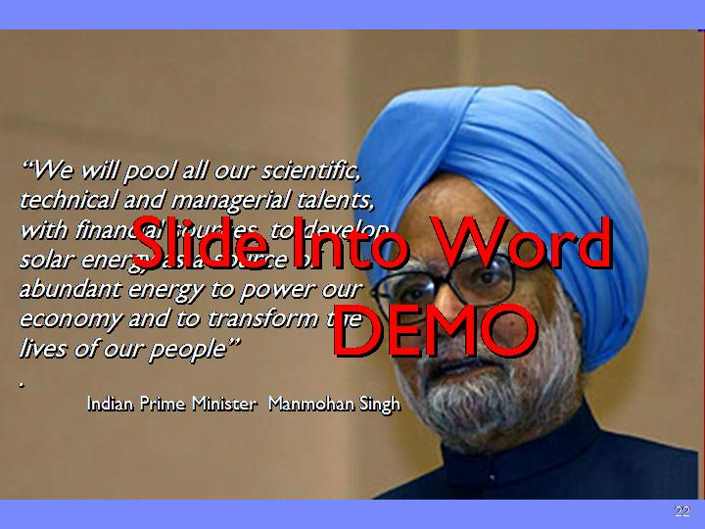 | - What’s so wonderful.. Is that it’s not just us making the point.. About the central role of engineering.  - <OBAMA INAUGURATION STORY>  - OTHER WOLRD LEADERS: Similar quotes form leaders world wide  - Sec’y of Interior Salazar said his second goal will be to work on a "moon shot" at energy independence. "We will do it now," he said. "It is an inescapable reality, it is an imperative."  - Japanese Prime Minister Taro Aso talks of "a great opportunity for new growth" and vows that "we will achieve the low-carbon society that is compatible with growth ahead of the rest of the world."  - French Prime Minister Nicolas Sarkozy, "by 2020, all new buildings should "produce more energy than they consume," ."  - Chancellor Angela Merkel said her government would this year “ set aside two billion euros for funding energy research in a bid to bolster the country's use of renewable energy. “  - Premier Wen "We must make conserving energy, decreasing energy consumption, protecting the environment and using land intensively the breakthrough point and main fulcrum for changing the pattern of economic growth,"  - India Prime Minister Manmohan Singh : “We will pool all our scientific, technical and managerial talents, with financial sources, to develop solar energy as a source of abundant energy to power our economy and to transform the lives of our people. Our success in this endeavor will change the face of India."  - SHOW UP: And the beauty is… We just have to show up !
Slide 23  Animation Clicks: 2 | 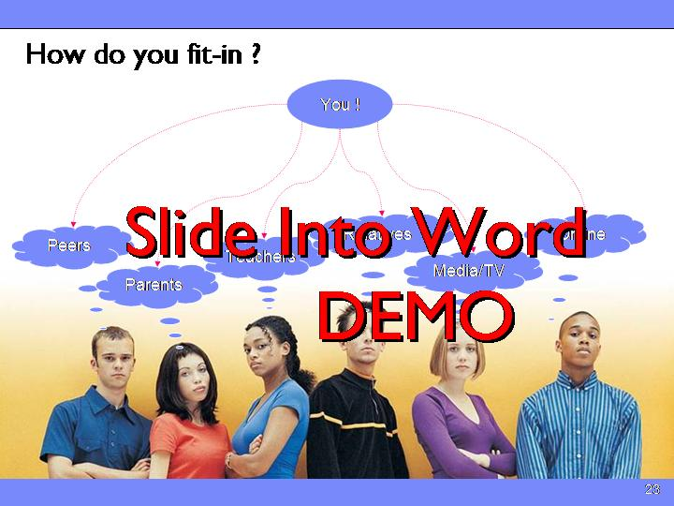 | - YOU ? So.. Where do we come in ? : It’s that part about ‘showing up’ We are the messengers  - Talk of a new message and new challenges is fine, but a new message alone will not change students’ attitudes about engineering. The message has to be delivered, understood, and above all, believed, to be effective. Who is going to deliver this new message? The answer is quite simple: you!  - So.. How do we go about reaching these kids ? Where do they get their perceptions ?  - WHO INFLUENCED YOU ? Think about who/what influenced you ?  - ROLES: Evidence from around the world shows that respected role models, whether they be teachers, parents, neighbors, community leaders, or media personalities, have the largest impact on career decisions for high school graduates. As a profession, we need to step up to the position of role model and demonstrate those aspects of the new messages involving creativity, collaboration, and world impact.  - In fact.. If you’re in this room.. It’s a good start.. Your kids are already 30 % more likely to choose a technical career because of you.  - See how important you are  - AGE: to be effective, we need to work this message at several levels. First and foremost, we need to reach the students before they have settled on a career choice which is generally they reach the 8th grade (13 years old).
Slide 24 | 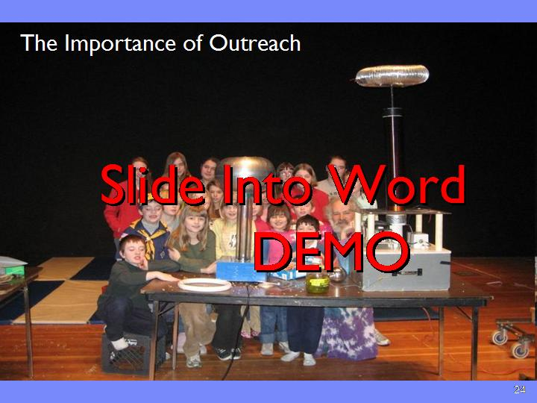 | - LOVE/PASSION Want to harness the love and get out there and interact with the next generation who are going to be addreesing these new world issues.  - We need to show them our passion for technology that is the reason that each and every one of us is in this room this morning.  - Make connection with the world.. Particularly with these global challenges that they already understand.@  - WHY: I do want to say here that doing outreach is not only important.. It’s  - Fun  - Good for your brain  - Career (if done in balanced way)  - Company  - Community  - Country  - And above all our planet  - PATH: So how do we do it ? . We’ll Here’s how I did it. . Maybe your path will be like mine .. Maybe not. There’s no silver bullet  - Start at home  - Work out to the schools  - Then out into the wider community  - Then further out into the world  - Your mileage will certainly vary
Slide 25  Animation Clicks: 3 | 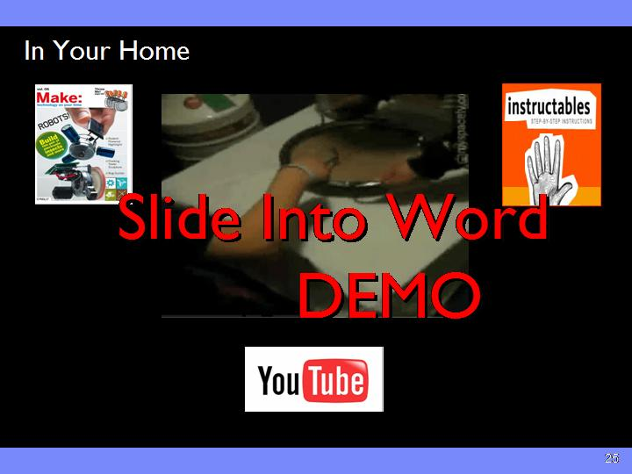 | - They say that Charity begins at home.. so does curiosity and interest ins science and technology  - HOBBY: Each of us has some special love for cool technology behind our industry.. If ou don’t.. Im sure that you did when you started.. Peraps you have a hobby, music, photography, programming that has a technical component.. We need to get back to the first hand geeky love of what we do.. Becaue when you love something.. Others will see  - For me .. It was easy.. I love electronics  - MY EXPERIENCE: My kids never expressed much interest until I linked it to something they liked,.. Photography and movie making..  - RENAISSANCE into the Renaissance in online resources.. That the internet has spawned.. Still spend all sorts of time looking at gismos and gadget folks from around the world have created..  - LINK TO ENERGY  - SHARE: Even shared a few of my own <ice cream story>  - YOUR PASSION : What’s your passion ? Find it and build on it, meet up with others on the web who share your passion.. And above all.. Show your kids, their friends and your neighbors the cool stuff you’re doing. .. It’s now ‘Chic to be a Geek’  - Kids passion to explore  Refs  - Make – online companion to Make magazine. The ultimate do-it-yourself resource for home scientists and inventors (http://www.makezine.com/). Make sponsors several regional MakerFaires and is about to go on public TV in the US (MakeTV).  - Instructables – More advanced do-it-yourself science and technology projects. The ultimate hackers resource (http://www.instructables.com/)  - Hackaday – Do-it-yourself site that finds unusual modifications to everyday things (http://hackaday.com/)  - Or try this popular favorite for extreme science: Bill Beaty’s Weird Science collection (http://www.eskimo.com/~billb/weird.html)..
Slide 26  Animation Clicks: 6 | 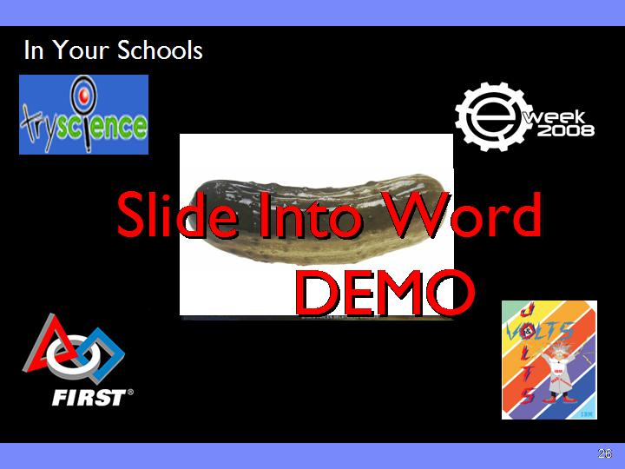 | - Once you get your chops up at home, it’s ready to share them with more kids..  - SHOW UP AT SCHOOL Show up at your local school  - Teachers will welcome you for your real world insight. One caution.. Ask them what they need first .. Instead of hitting the m over the head with your ideas.  - My first experience – simple density (I was nervous). So many resources online.. Just look or check my paper.. Or site johncohn.org for ideas. Or send me some of yours  - EWEEK I then graduated to eWEEk . An international program .. Your company probably participates.. If not.help them start ! Great way to get started.. Pair up with others, learn from them . Link to Energy !  - FIRST Somewhere in there I starting to get involved with International robotics team coaching.. Like sports for geeks ! Has three levels. Getting more involved this year. Check out FIRST  - JOLTS/VOLTS Over the years I also created my own mad science program.. Jolts and volts (30-40,000 kids)  - Everyone I know who’s tried it gets hooked.. Some so much that they decided to take up teaching as a post-retirement 2nd career.. Transition to teaching  <pickle demo> 119  Refs:  - http://johncohn.org – see outreach links .. Or send me your own  - TryScience – easy, well-tested individual and classroom science projects (http://tryscience.org/)  - Science Buddies – science fair project ideas for all levels with online mentoring (http://www.sciencebuddies.org/)  - Or check one of these handy sites for links to many other home science and engineering websites: Science Experiments for Kids (http://homeschooling.gomilpitas.com/explore/sci.htm) or K-12 Science Education (http://dir.yahoo.com/Science/Education/K_12).  - Corporate Outreach Programs: Most large companies offer outreach programs such as IBM’s On Demand Community[i], Intel’s Education Initiative[ii], Cisco’s K-12 Education Outreach Program[iii], or Motorola’s Community Investment Program[iv]. If your company doesn’t have an organized science and engineering outreach program, start one!  - eWeek: If you are interested in more structured outreach activities, get involved in National Engineers Week (eWeek), the international outreach week for the engineering community. The eWeek website includes activity ideas and career information (http://www.eweek.org/). Ask your employer if they participate in eWeek. If they don’t, help them start!  - Project Lead the Way (PLTW) (http://www.pltw.org)  [i] IBM’s On Demand Community. https://www-01.ibm.com/ibm/ondemandcommunity/home/index.jsp  [ii] Intel’s Education Initiative. http://www.intel.com/education/  [iii] Cisco’s K-12 Education Outreach Program. http://www.cisco.com/web/about/ac49/ac55/outreach/education_k-12.html  [iv] Motorola’s Community Investment Program. http://www.motorola.com/content.jsp?globalObjectId=8135
Slide 27  Animation Clicks: 4 | 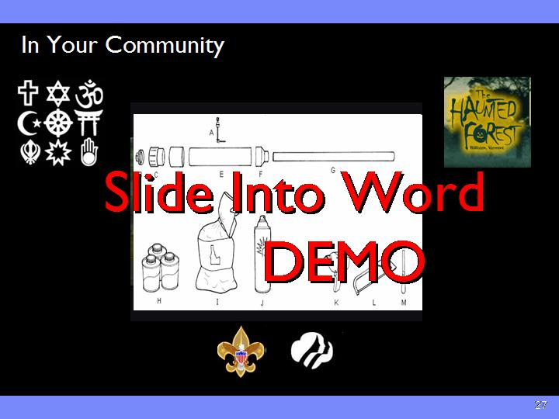 | - When word gets around that you’re passionate about what you do, opportunities just start appearing..  - It wasn’t’ long before I was giving talks and demos in church groups, summer camps, museums, etc ..  - COMMUNITY ORGS: Check in your community.. You’ll probably find lots of opportunities from folks who are trying to keep kids busy and interested..  - SPECIAL PROJECTS: Occasionally something really unusual comes up. That is a perfect place for a group of engineers to show off their love and passion for science..  - Haunted Forest .. 20 foot tall robotic monster jumping out to scare kids at a Halloween fund raiser  - Group of us VoMIT.. Coordinated group of volunteers, engineers, inventors, high school and college kids  - Covers in TV over 7000 folks got to see the joys of engineering !  - <play video>  - SCOUTING: You’ll find other places in the community you can help out.. Like International boy and girl scouting.. They need help with activities, merit badges, etc.  - I remember showing a troop how to make one of these:  - <SPUD GUN>  Refs  - FIRST Robotics Competition – advanced robotics competition that makes learning about technology into a sport ! (http://www.usfirst.org/)  - FIRST Lego League – international LEGO robotics competition (http://www.firstlegoleague.org/)  - Odyssey of the Mind – international creative thinking competition (http://www.odysseyofthemind.com/)  - Global Challenge – competition that brings together global teams to collaborate to solve worldwide problems (http://www.globalchallengeaward.org/)
Slide 28  Animation Clicks: 4 | 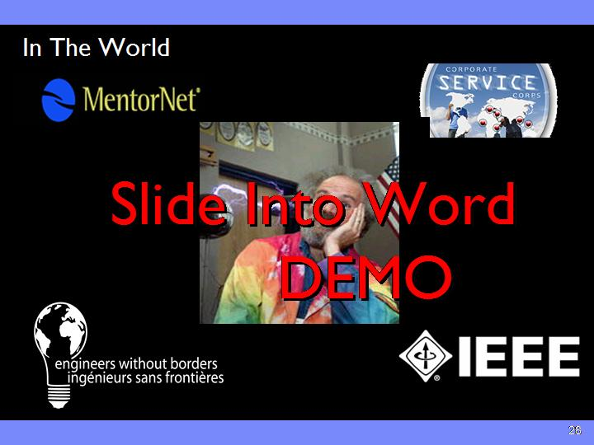 | - My own path got me interested in how I could extend the reach of the outreach I did.. I began looking for ways to use what I know to help others in other parts of the world.  - MENTORING: Came across MentorNet through Machoka Minds.. A program my company has to pair engineers with high school and college kids in emerging parts of the world.. <Peliera story>.. You can join mentor net, too. It’s free !  - SERVICE CORP: Company has several other outreach activities including Service Corps.. Folks go over in teams to solve real engineering problems. Here’s one of our first teams we sent to Ghana to work on water. Check with your company or institution.. There are many orgs like this sporting up.. Might be a really cool way to take a meaningful working vacation.. Link to climate/water.  - EXPATRIATE GROUPS: eg. ASHA  - EWB: If your company doesn’t have one, check out Engineers Without Borders.. Local chapters all over the world. We’ve got a student chapter in our town.. Note.. All women !  - IEEE: Finally.. Our own IEEE has great outreach opportunities all aroudn the world.. Tou can do projects, tlak to kids, ehlp creat cirriculm.. Or make talks on topics that you’re passionate about.. LIKE THIS ϑ  Refs  - Service Organizations: Perhaps the best established of these is Engineers Without Borders (http://www.ewb-international.org/), an international service organization for engineers modeled after the now famous Doctors without Borders. EWB helps organize teams of engineers to solve pressing problems in parts of the emerging world. It’s a great way to give back to the world. EWB has chapters in many cities and countries. Check their website to find a chapter near you.  - Expatriate Groups: Other worldwide efforts include expatriate groups like ASHA (http://www.ashanet.org/) that help support education in places like India.  - University Programs: Many universities have technical outreach programs such as the MIT D-Lab (http://web.mit.edu/d-lab/) that couples student innovation with real-world need.  - Professional Organizations: Organizations like the IEEE (http://ieee.org) have many outreach activities such as the Pre-University Outreach Program (http://www.ieee.org/web/education/preuniversity/home.html). You can help make them stronger.
Slide 29  Animation Clicks: 1 | 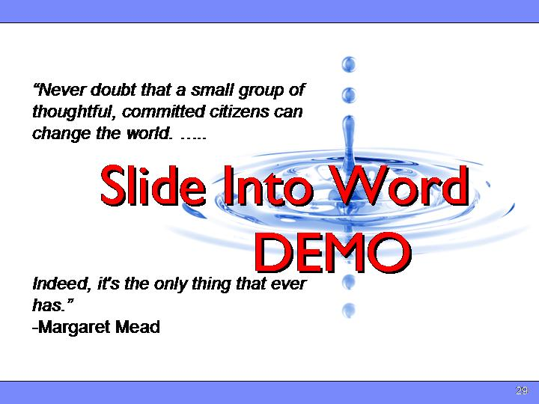 | - START: So.. If you’re not doing outreach ? Please commit to start... If you’re already doing it.. Good for you.. See How do you kick it up a bit ?  - DIFFERENCE: You may ask.. Will my efforts make a difference ?  - In fact.. It’s the Only thing that can make a difference..  - THANKS: Thank You Very Much

